**Sprint 2 Report**

Title: Summarize Everything

Team: Summarize Everything

Feb. 8, 2022

**Actions to stop doing**

* Neglecting scrum board. The team should stop doing this because it makes the current status of tasks unclear.
* Not adding comments to code that describes functionality because this makes downstream developers who may be depending on older code to create new functionality

**Actions to start doing**

* Start assigning tasks even before we have time to work on them (queue tasks). This would prevent situations where the team does not know what needs to be done next.
* Begin doing QA more frequently instead of at the end of sprint (work in branches, merge large features). This would help resolve issues earlier and reduce the amount of time necessary to fix them.
* Develop a more concrete understanding of product branding. This would help the team know what the design of the product should look like.

**Actions to keep doing**

* Commit frequently and use automated tools like github actions. This helps the team have a better idea of the current progress.
* Maintain a consistent “style” of coding, where commonly used items and functions have their place and new code is updated and compartmentalized.

**Work completed/not completed**

* *Completed*
  + API linking between frontend and backend
  + .txt file / text verification
  + Text character count
  + Error alerts
  + Summarized content is displayed
* *Not Completed*
  + Fixes to HTTP timeouts

**Work completion rate**

* # of completed User Stories: **5 of 5**
* Estimated work hours from sprint: **13.5 hr**
* # of days in sprint: **14**

**Completed Scrum Board**

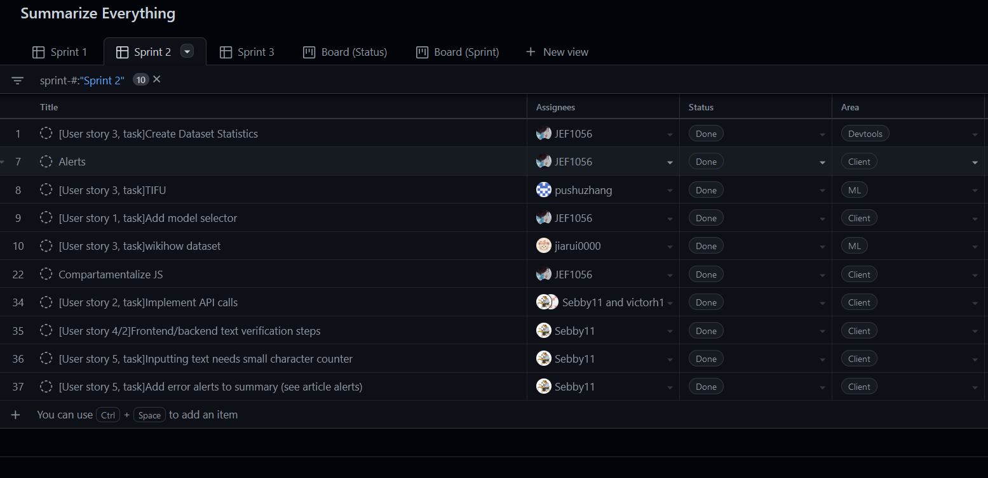

**Completed Burnup Chart**

